Design Decisions
This project recreates the desk photograph I chose in Milestone One (Burst, n.d.; see Figure 1) as a low-poly scene. Each object was broken into basic meshes: the desk is a plane, the mug is a cylinder body with a torus handle, the washi tape is a flattened torus, the books are three slightly rotated boxes, and the lamp combines two cylinders, a sphere, and a cone. Together these use six primitive types, and each mesh is loaded once and reused for every draw. The desk and mug use 1024 by 1024 textures, and UV scaling tiles each one so its pattern keeps a natural size. Three lights (a warm point light, a dim cool blue point light, and a soft directional fill) use ambient, diffuse, and specular components, and each surface has its own material so the glossy mug, matte books, and metal lamp respond to light differently. The blue light sits behind the desk so the far sides of the objects stay visible when the camera moves around the scene. Because only one torus mesh exists in memory at a time, the mug handle and the tape roll share it and differ only in scale, rotation, and position. I chose a cone as a shade cap over the lamp bulb because it read clearly as a lamp at low polygon counts.
The code also reflects the feedback from earlier milestones. To encapsulate objects, I created a SceneObject class that holds a list of ObjectPart structures, each storing a shape, transformation, texture or color, and material. Texture tags, material tags, dimensions, and positions are named constants, and RenderScene() is now a short loop over the objects. LoadTextureWithCheck() tests the result of CreateGLTexture(), prints a warning on failure, and lets the object fall back to a solid color. The console also prints the controls at startup, logs each change between the two views, and reports the camera speed whenever the scroll wheel is used. Together, these changes make the program easier to read, extend, and debug.
The user navigates with a free-flying camera. W and S move forward and backward, A and D move left and right, and Q and E move up and down. Moving the mouse changes the viewing direction, and the scroll wheel changes the movement speed, which is printed to the console. Movement is multiplied by the frame time, as in g_pCamera->ProcessKeyboard(FORWARD, gDeltaTime), so speed stays consistent on any computer. Pressing P selects the perspective projection, and pressing O selects an orthographic view from a fixed, level camera that shows the scene without perspective distortion. The orthographic view is wide enough to include the books and lamp at either end of the desk, and the desk plane is seen edge-on so the objects stand out clearly.
Several custom functions keep the program modular. BuildSceneObjects() calls one builder per object (BuildDesk(), BuildMug(), and so on), and the builders use MakeTexturedPart() and MakeColoredPart() so a new part takes a single call. RenderObject() applies each part’s transformation, surface, and material, and then draws the matching mesh. DefineObjectMaterials() and SetupSceneLights() keep the lighting setup separate from drawing, and PrintControls() documents the navigation for the user. The classes and functions are written to be reused: adding a new object to a future scene requires only one builder function and one line in BuildSceneObjects(), and no changes to the drawing code. Comments above each function describe its purpose, and constants replace repeated numbers and strings so that a value only needs to be changed in one place.

References
Burst. (n.d.). Books, cup of coffee, desk, laptop [Photograph]. Pexels.
https://www.pexels.com/photo/books-cup-of-coffee-desk-laptop-373892/

Figure 1
Desk Workspace Photograph Used as the Reference for the 3D Scene
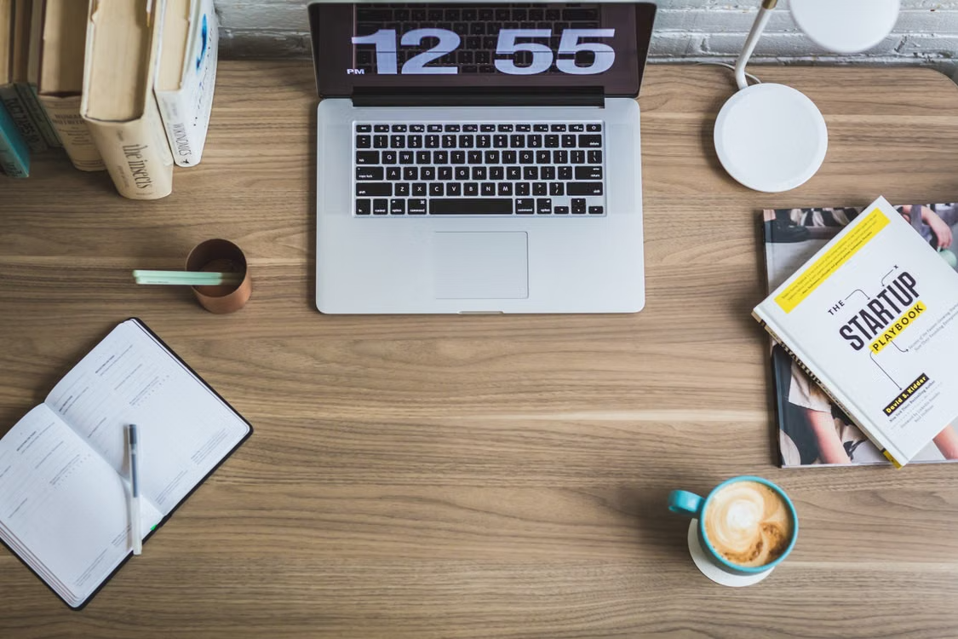
Note. From Books, Cup of Coffee, Desk, Laptop, by Burst, n.d., Pexels (https://www.pexels.com/photo/books-cup-of-coffee-desk-laptop-373892/).

